 Line of Business: User Interface

Investigation Exercise

1. Open config.xml. What are the names of the two configuration parameters that control whether the "Choose by Coverage" or "Choose by Coverage Type" menus are displayed for a given line of business?

2. Which loss type in the base application is not listed in the default settings for these two parameters? (If necessary, view the LossType typelist in the data dictionary or in Studio.)

3. Modify config.xml as described below. (You must restart ClaimCenter to deploy config.xml changes.)

- For auto claims (such as claim 235-53-365870), exposures are created only as shown below:
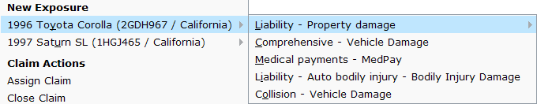

- For property claims (such as claim 426-24-366070), exposures are created only as shown below:
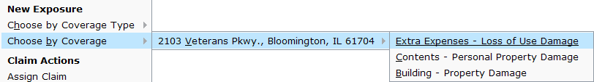

- For general liability claims (such as 345-50-123321), exposures are created only as shown below:
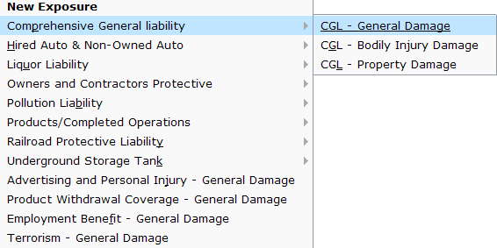
Configuration Exercise

Configure ClaimCenter to meet the following customer requirement from Acme Insurance.

Requirement: Eroded Property Damage for Erosion Coverage

In the previous lab, you configured ClaimCenter to include a new Erosion coverage for Homeowner's policies.

The business analysts at Acme Insurance have decided that the type of information needed for an erosion exposure is significantly different from that of other exposures with the Property exposure type. Therefore, the Erosion coverage needs its own exposure type.

Before you begin configuring, read through #7, which contains some notes and hints from the ClaimCenter implementation team.

4. Create a new exposure type called "Eroded Property Damage" (internal code "ErodedPropertyDamage"). Modify the line of business model so that this exposure type is the only exposure type associated to the Erosion coverage type. Your new exposure should be tied to the DwellingIncident.

5. Create a detail view to be used for creating erosion exposures on an existing claim. For now, the new detail view can be identical to the one used for property damage (to duplicate a PCF, select it in Studio’s “Resources” pane, then choose “Duplicate” from the Edit menu). The new detail view should have a label at the top of the detail view which reads:

"Remind the insured that new legislation in 2008 may limit erosion coverage in coastal regions."

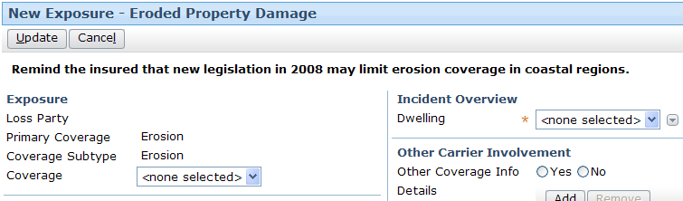

6. Create a detail view to be used for viewing exposures on an existing claim that use the "Eroded Property Damage" exposure type. (Normally, you would also create detail views for the New Claim Wizard and FNOL snapshot. To keep the lab at an appropriate length, these detail views do not need to be done.) For now, the new detail view can be identical to the one used for property damage, but the new detail view should have a label at the top of the detail view which reads:

"Remind the insured that new legislation in 2008 may limit erosion coverage in coastal regions."

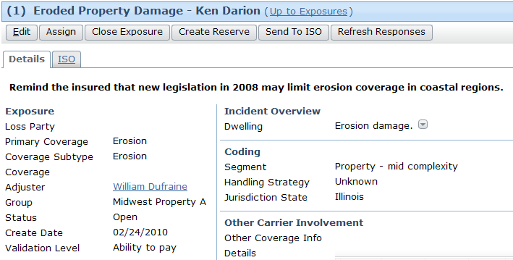

7. The ClaimCenter implementation team has provided additional notes:
- When you update the data model, you can either reuse the existing CoverageSubType that you created in the previous lab, or you can retire the old CoverageSubType and create a new one. If you create a new one, you will want to also update the LossPartyType typelist.
- The new detail view will be similar to the NewExposureDV.Propertydamage and ExposureDetailDV.Propertydamage detail view. Therefore, they recommend that you use copies of each of these detail views as the starting point.
- Hint: There is no need to create a label widget to add the text at the top of the detail views. You can use a “Verbatim” widget. Search for this widget in the Studio toolbox.
- Hint: There are some modal elements on the two detail views. Duplicate each modal element (i.e. create a new file) for the new ErodedPropertyDamage exposure type (new mode → new file.)
- Hint: It will be necessary to update the initializeIncident() function in the ExposureUI.gsx module to include a case for your new exposure type.

Test Cases

You may need to delete the db directory, restart the server, and then reload the sample data again (see Configuring LOB Typelists lab for details.) It depends on exactly what you did to solve this exercise.

When you have completed your configuration, run the following test cases:

8. Log on as William Dufraine Using a homeowner's claim, such as claim 426-24-366170, create an erosion exposure. You should now see your new form and new exposure type. Then, save the exposure and verify you can view it in detail after it has been saved.

